
RECORD 12 Braunston Cubs earn top award
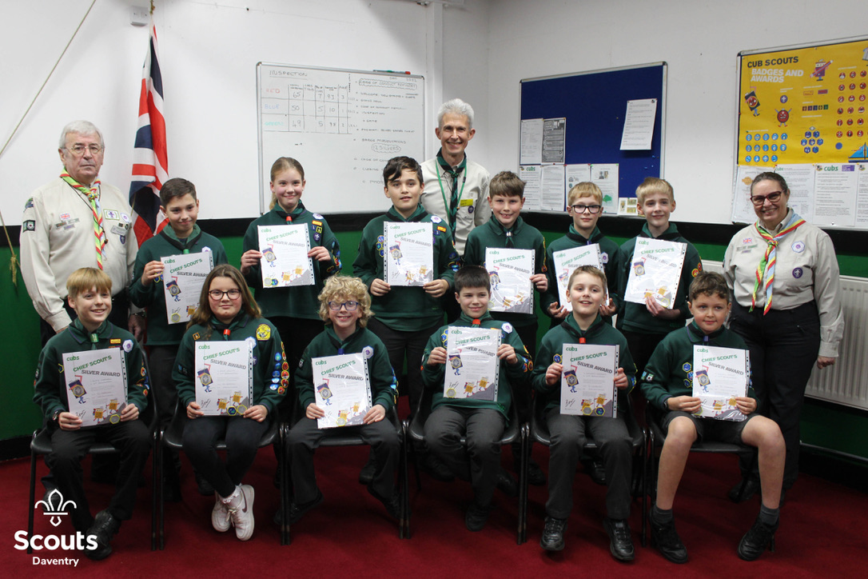

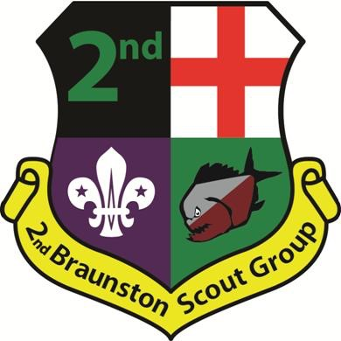
12 Cubs from Braunston have just been awarded the Chief Scout Silver award. That’s 14 Silvers in 1 year, a new record. In recognition of this outstanding achievement Irene Lockley & Patrick Richardson from Daventry District Scouting presented the certificates and the moment was captured by Northants County photographer David Curtis.

Silver is the highest award a Cub can earn covering: Adventurous & Outdoor activities; Skills, Personal challenges, Teamwork & Team Leading and Global awareness PLUS a minimum of 6 other badges. Cub leader David Coleman said “they are all super Cubs, and a credit to scouting, I am immensely proud of them all”

Website: https://www.braunstonscouts.co.uk/
david@braunstonscouts.co.uk

